5.2 Object interaction models
Copy the block below for at least two of the use cases in 4.1; preferably including your riskiest.
5.2. UC-01 [Find Room Matching Study Needs]
(a) Non-trivial steps:
Filtering: RoomCatalog works with SearchCriteria to find study rooms matching the student's needs.
Generating reported labels: RoomCatalog helps derive and display labels for matching rooms.
Looking up selected-room details: RoomCatalog retrieves details of the selected StudyRoom.
Both initial presentation and final acknowledgment only display information to the user and require no additional domain processing, so they are trivial steps

(b) Scenario table.
Step | Subject (who  acts) | Subject action (what it does) | Other data/objects (what is used) | Object acted upon (who receives)
1 | Student | Request characteristics of the room | Building, Amenity | SearchCriteria
2 | SearchCriteria | Find qualifying rooms | Building, Amentity | StudyRoom
3 | StudyRoom | Asks for the latest report for each result | OccupancyReport | DisplayedRoomStatus
4 | DisplayedRoomStatus | Returns correct reported labels | submissionTime, acceptanceOrder | StudyRoom
5 | StudyRoom | Shows qualifying rooms with labels | DisplayedRoomStatus | Student
6 | Student | Choose a study room | roomIdentifier | StudyRoom
7 | StudyRoom | Get the latest report of the selected room | submissionTime, acceptanceOrder | OccupancyReport
8 | StudyRoom | Shows selected room details | Amenity, latestReportTime | Student

(c) Analysis sequence diagram.
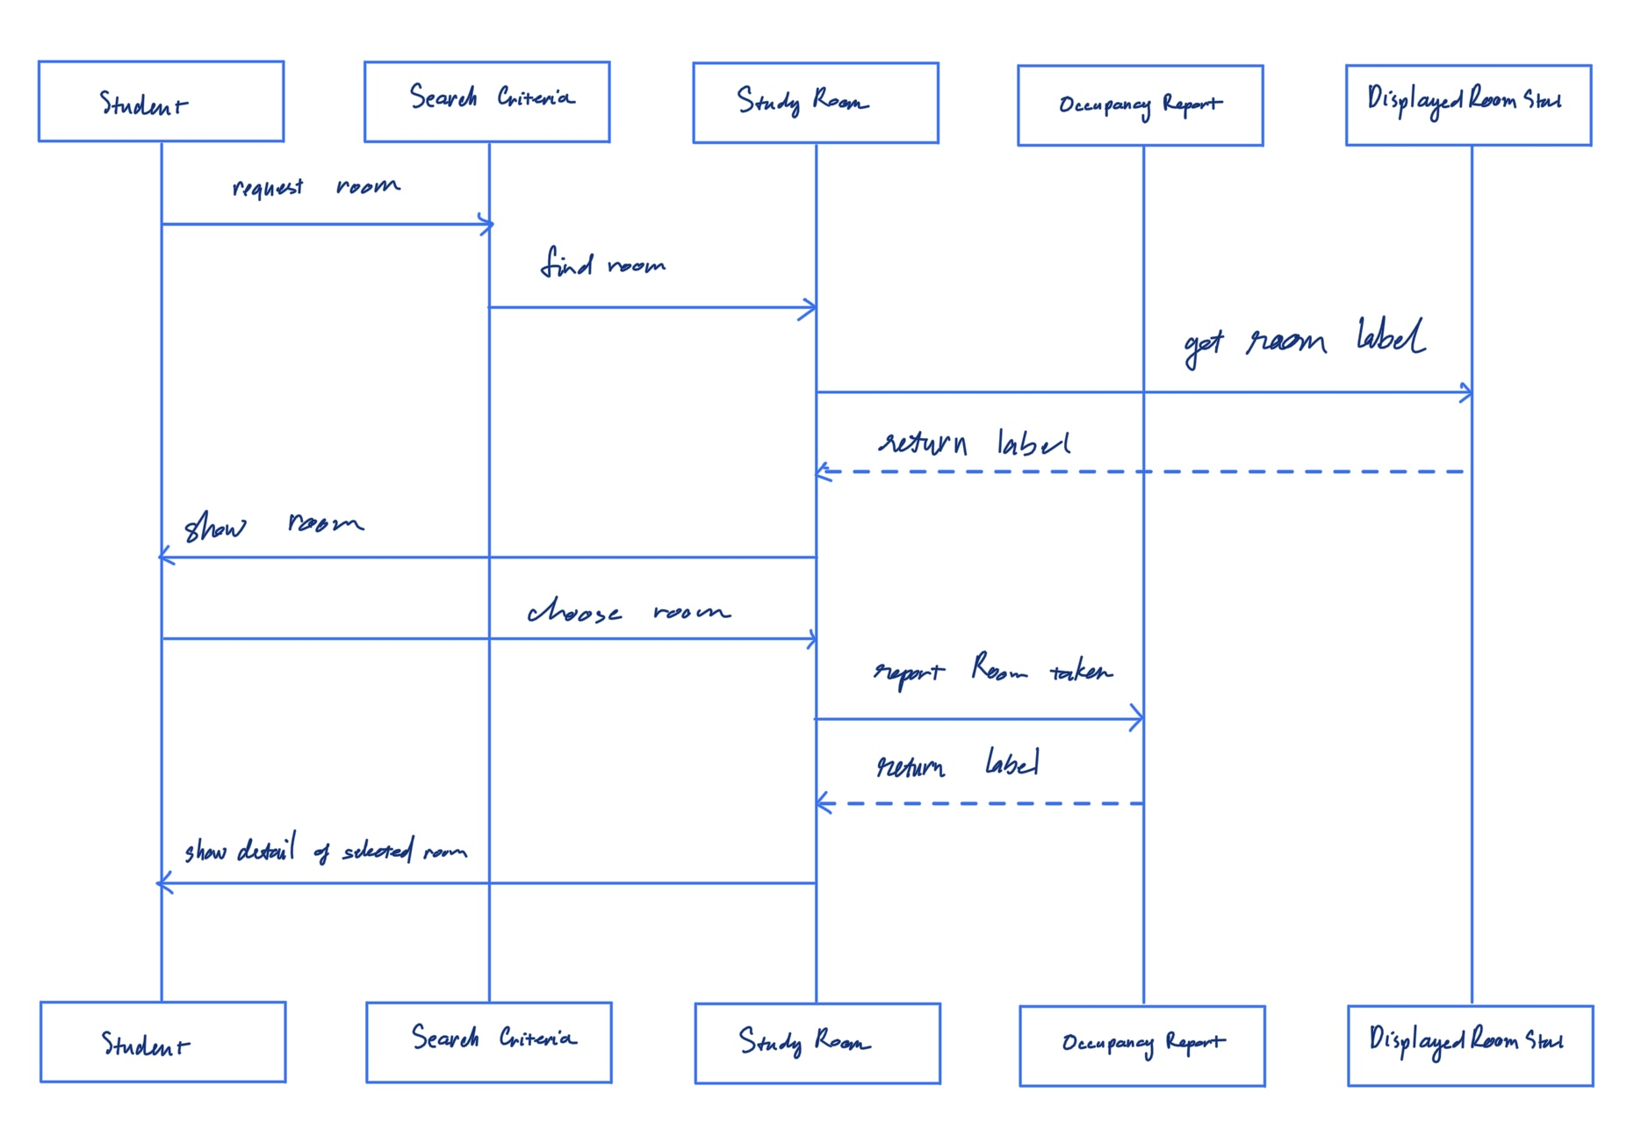

5.2. UC-02 [Report Room Occupancy]
(a) Non-trivial steps:
Input checking: The system validates the submitted information to ensure it is correct and complete.
Atomic report acceptance: The system uses OccupancyReport to ensure it accepts and stores a report as a single operation.
Server time/order: The system records the submission time and acceptance order for each report.
Displayed status: DisplayedRoomStatus determines the current occupancy label based on the latest accepted report.
Both initial presentation and final acknowledgment only display information to the user and require no additional domain processing, so they are trivial steps

(b) Scenario table.
Step | Subject (who  acts) | Subject action (what it does) | Other data/objects (what is used) | Object acted upon (who receives)
1 | Student | Choose a room to report | SearchCriteria | StudyRoom
2 | StudyRoom | Display details of the chosen room | Building, Amenity | Student
3 | Student | Submit an occupancy report | StudyRoom | OccupancyReport
4 | StudyRoom | Validate the submitted report | OccupancyReport, observation | OccupancyReport
5 | OccupancyReport | Record the submission data | submissionTime, acceptanceOrder | StudyRoom
6 | StudyRoom | Get the current occupancy status using the latest accepted report | OccupancyReport | DisplayedRoomStatus
7 | OccupancyReport | Display confirmation of a successful report | OccupancyReport | Student

(c) Analysis sequence diagram.
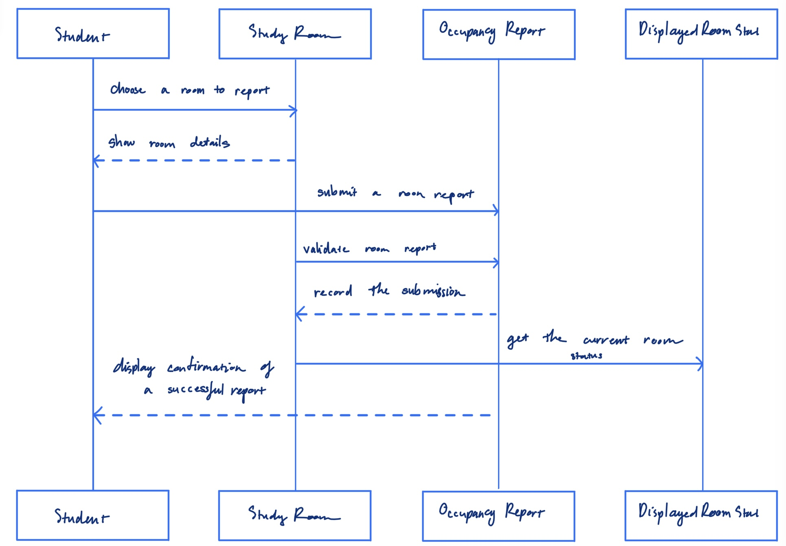

5.2. UC-04 [Check Room Occupancy]
(a) Non-trivial steps.
Input checking: Validate the user's search criteria to ensure they are valid.
Room filtering: RoomCatalog uses SearchCriteria, Building, and Amenity to find matching rooms.
Occupancy lookup: StudyRoom retrieves its latest OccupancyReport to determine the current occupancy.
Status derivation: DisplayedRoomStatus determines whether the room is Empty, Occupied, or Unknown.
Both initial presentation and final acknowledgment only display information to the user and require no additional domain processing, so they are trivial steps

(b) Scenario table.
Step | Subject (who  acts) | Subject action (what it does) | Other data / objects (what is used) | Object acted upon (who receives)
1 | Student | Select a building | Building | SearchCriteria
2 | Student | Specify minimum capacity and desired amenities | Amenity, minimumCapacity | SearchCriteria
3 | SearchCriteria | Validate the selected | Building, Amentity | StudyRoom
4 | SearchCriteria | Find rooms matching the search criteria | Building, Amenity | StudyRoom
5 | StudyRoom | Retrieve the latest occupancy information | OccupancyReport, submissionTime, acceptanceOrder | DisplayedRoomStatus
6 | DisplayRoom Status | Determine the current occupancy label (Empty, Occupied, or Unknown) | OccupancyReport, latestReportTime | StudyRoom

(c) Analysis sequence diagram.
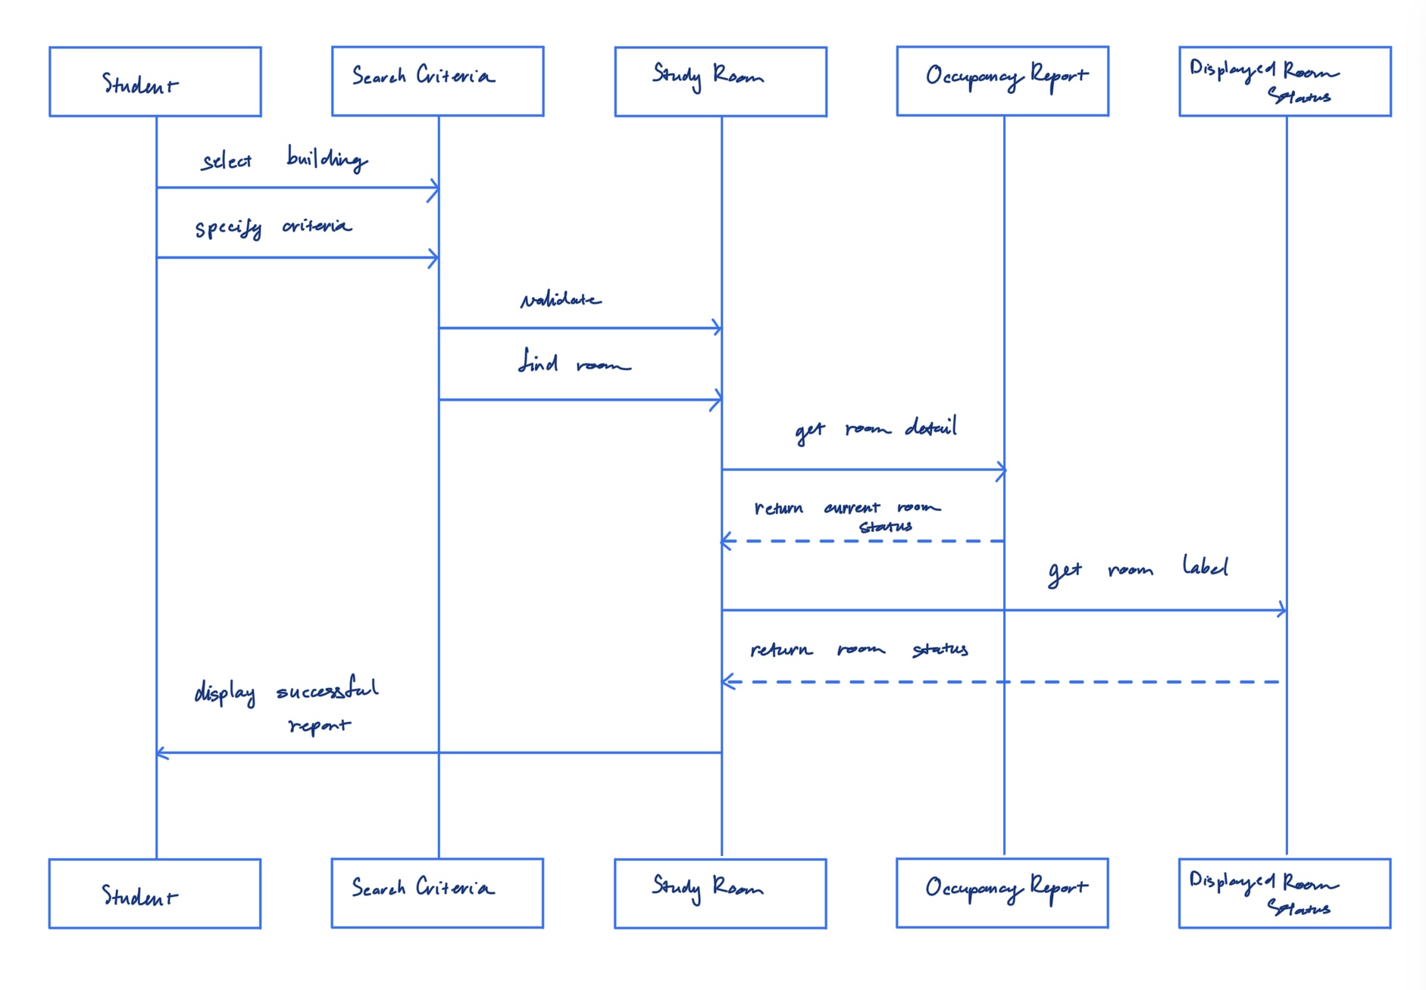

Figure 5.2.x Analysis sequence diagram for UC-xx; message numbers match the scenario table

CS 3354 · P2 Analysis and High-Level Design · Template | Page 10
CE/CS/SE 3354 · Software Engineering · Fall 2026
5.3 Consistency cross-check
Check | Result (pass, or what  failed) | Fixed in
K1 Every item in an actor column (4.2) is an attribute in the domain model (5.1) | Passed | x
K2 Every object on a sequence diagram is a domain class or a declared interaction object | Passed | x
K3 Every message on a sequence diagram  corresponds to exactly one scenario-table row | Passed | x
K4 Every non-trivial step in 5.2 (a) has at least one scenario-table row | Input validation was not listed as one of the step for UC-2 and UC-4 | Fixed in IC-2 (added step 5), UC-4
K5 Every analyzed use case traces to at least one functional requirement | Passed
K6 The last messages of each diagram make the use case postcondition true | Missing in UC-4 | Added a message that let the user knows the operation was a success in the diagram.

GUIDANCE: DELETE THIS BOX BEFORE SUBMITTING
Run the six checks across the work of different authors; they are designed to catch the seams between people. A failed check that you found and fixed is more convincing than a column of passes. Budget: a quarter of a page.

